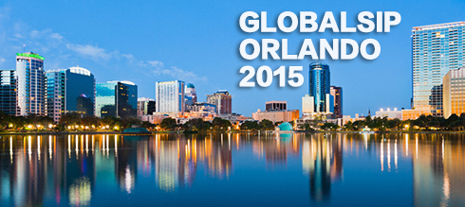 |   CALL FOR PARTICIPATIONS
GlobalSIP’15 GeneralChairs:Jose Moura andDapeng Oliver Wu
TechnicalProgramChairs:Mihaela van der Schaar, Xiaodong Wang, and Hsiao-Chun Wu
URL: http://2015.ieeeglobalsip.org/

TheIEEEGlobalConferenceonSignalandInformationProcessing (GlobalSIP)isarecentlylaunchedflagshipconferenceoftheIEEESignalProcessing Society.GlobalSIP’15willbeheld inOrlando,Florida,USA,14-16 December2015.Theconferencewillfocusbroadlyonsignalandinformationprocessingwithanemphasisonup-and-comingsignalprocessingthemes.Theconferencewillfeatureworld-classspeakers,tutorials,exhibits,andtechnicalsessionsconsisting ofposterororalpresentations.GlobalSIP’15technical program will be comprised of a main program (General Symposium) and several collocated symposia on special topics. Technical papers submitted to GlobalSIP’15addressa number of topics:

- Signal processing in communications and networks, including green communication and Signal processing in optical communication
- Image and video processing
- Selective topics in speech and language processing
- Signal processing in security applications
- Signal processing in energy and power systems
- Signal processing in genomics and bioengineering (physiological, pharmacological and behavioral)
- Signal processing for social media networks
- Neural signal processing
- Seismic signal processing
- Hardware and real-time implementations
- Other novel and significant Applications of selected areas of signal processing

Symposia:

- General Symposium
- Symposium on Signal Processing on Graphics Processing Units and Multicores
- Symposium on Signal Processing in Mobile Multimedia Communication Systems
- Symposium on 3GPP EVS and beyond
- Symposium on Signal and Information Processing for Optimizing Future Energy Systems
- Symposium on Signal Processing Challenges in Human Brain Connectomics
- Symposium on Real-Time Signal Processing for Low-Cost and Low-Power Smart Devices
- Symposium on Signal Processing for Optical Wireless Communications
- Symposium on Signal and Info. Processing for Software-Defined Ecosystems, and Green Computing
- Symposium on Signal Processing Applications in Smart Buildings
- Symposium on Signal Processing and Mathematical Modeling of Biological Processes with Applications to Cyber-Physical Systems for Precise Medicine
- Symposium on Massive MIMO and Full-Dimension MIMO (FD-MIMO) Communications

Important Deadlines for Participations:
Advance Registration (discounted rate) 30 October 2015
Full registrations and one-day registrations at full rate cover lunches, breaks, and receptions.

